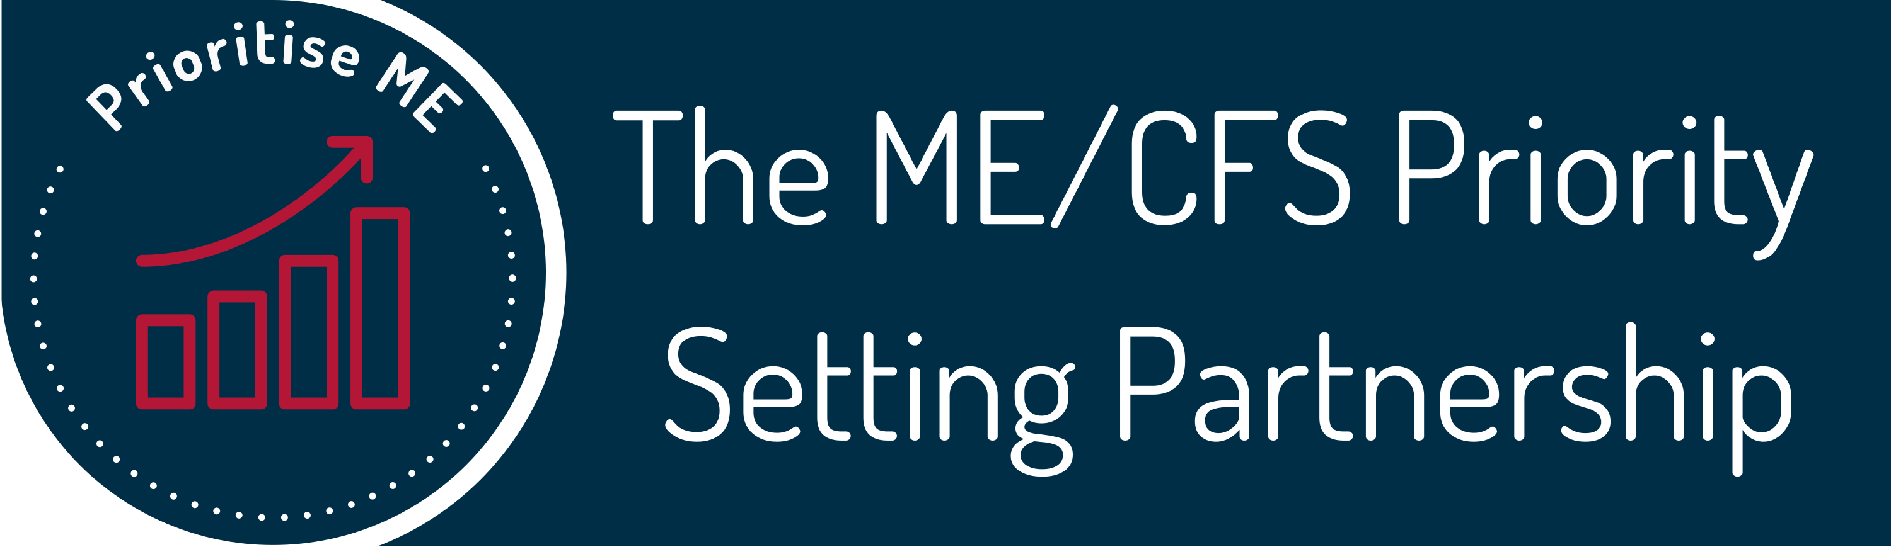

Are you interested in joining our Zoom workshops to set research priorities for ME/CFS?
ME/CFS Final Priority Setting Workshops
March 2022
Are you ...
- a person with ME/CFS?
- a carer or supporter of someone with ME/CFS?
- a healthcare professional working with people with ME/CFS?
You can help prioritise the top ten questions for research.

The ME/CFS Priority Setting Partnership (PSP) is following an approach tried and tested by the non-profit making initiative, the James Lind Alliance to determine the questions that matter for research, from the perspective of people with ME/CFS, their carers and supporters and healthcare professionals.

When and where?
The workshops will take place on Zoom:
- Saturday 5th March 1.00pm – 2.30pm
- Thursday 10th March 5.30pm -7.00pm
- Friday 18th March 2.00pm - 4.00pm
The event is spread across three dates to allow time for recovery, and there will be rest breaks in each workshop. We need you to be at all three sessions. You may of course consider naming a proxy who can step in on your behalf at any time should this prove necessary.

We will be using Zoom, and will provide guidance on how to connect if you are new to Zoom. Practice sessions will be available. Ideally you will have a computer or tablet to connect to the workshop. Joining on a mobile device or by dialling in will have limitations, but we will do all we can to enable your full participation.

What are the workshops for?
The aim of the workshops is to agree the top ten questions for research into ME/CFS which matter most to people living with ME/CFS, carers and supporters and healthcare professionals who work with them. These questions will add a new perspective to the research agenda for ME/CFS.

Over the last year we have asked people with ME/CFS, carers and supporters and health care professionals to tell us the questions they wanted answering by research. Over 5,300 ideas were submitted. These questions were reviewed, collated and summarised, into a long list of 59 questions. These 59 questions have now been prioritised by over 2,000 people who engaged in our second survey, giving a shortlist of about 15 questions which will go to the final workshops.
We now need your help to finalise the top ten!
These final workshops are an opportunity for different people to express their views and hear different perspectives about ME/CFS research priorities. There is immense value in bringing people together to engage in careful consideration and quality discussion to make shared decisions and reach genuine consensus.

Who are we looking for?
We want to recruit approximately 30 people who have lived experience of ME/CFS, carers and supporters including family, and healthcare professionals working in this field. This includes people with all severities of ME/CFS.

What do I need to do at the workshops?
You should be prepared to share your experiences and opinions, and listen carefully to other people, in a series of small group discussions. There will be about five people in each small group at the workshop.
Together, you will be helping us to make decisions about the top 10 research questions you think should be prioritised.

How do I apply?
If you are interested in taking part in the workshops, please complete the expression of interest form on the following pages and return it by midday Tuesday 11th January 2022.
We will accept online, email or hard copy applications. The postal service is in high demand right now and some mail is delayed so you might choose to try and submit your form to us online if at all possible.
You can complete the form online at www.psp-me.co.uk/take-part
If you want to you can email your form to questions@psp-me.co.uk or you can return it via post but it must arrive before the closing date. This is a freepost address, so no need for a stamp:
FREEPOST Plus RTJR-TREB-AXGY
42 Temple Street
Keynsham BS31 1EH

For more information about the workshops go to www.psp-me.co.uk/workshops

Thank you for your interest in this exciting project.

ME/CFS Priority Setting Workshop - Expression of Interest Form
Full name
Email address
Please click the box that best represents you. | ☐ Anyone aged 16+ who has been diagnosed with ME/CFS at any time  ☐ Carers, friends, family and supporters, including parents of children with ME/CFS  ☐ Health and care professionals who work with people with ME/CFS  ☐ Other, please specify:

Brief statement about why you are interested in taking part in the workshop (max 200 words)

Do you have any competing interests that could be seen to influence your participation? (Click the box) | ☐ Yes  ☐ No
If ‘Yes’, please describe your interests and how you will manage them.

Please indicate which dates you are available to attend the workshop sessions. (Click the boxes)  We really need you to be at all three sessions, if possible. But you can also have a proxy who can step in on your behalf at any time. | ☐ Saturday 5th March 1.00pm -2.30pm  ☐ Thursday 10th March 5.30pm -7.00pm  ☐ Friday 18th March 2pm-4pm
Your preferred telephone number.
We may use this if we need to contact you because of technical problems during the workshop

Details about you
Are you likely to have a proxy who you will ask to step in on your behalf, if you need to take a break? | ☐ Yes  ☐ No
If yes, please provide the name of your proxy, if you know who it is (you can always let us know later).
What gender do you identify as? | ☐ Male  ☐ Female  ☐ Prefer to use my own term  ☐ Prefer not to say
Which option best describes your ethnic group? | ☐ White  ☐ Mixed/Multiple ethnic groups  ☐ Asian/Asian British  ☐ Black/African Caribbean/Black British  ☐ Other ethnic group  ☐ Prefer not to say
Where do you usually live? | ☐ England  ☐ Northern Ireland  ☐ Scotland  ☐ Wales  ☐ Other, please specify:

These questions are for people with ME/CFS and their carers only
Please indicate the severity of your ME/CFS, or the person you care for, at the moment?  Please note, this is not a question about how severe your suffering is, but of how badly affected you are in comparison with other people with ME/CFS. Please tick the box that is the closest fit. | ☐ Mild  ☐ Moderate  ☐ Severe | ☐ Very severe  ☐ In remission
Which age group are you, or the person you care for/support? | ☐ Under 16  ☐ 16-24  ☐ 25-44 | ☐ 45-64  ☐ 65+
How long ago did you, or the person you care for, first become ill with ME/CFS? | ☐ Up to 1 year ago  ☐ Between 1 and 5 years ago  ☐ Between 5 and 20 years ago  ☐ Over 20 years ago

This question is for health and care professionals only
Please indicate your job title or role here:

The deadline for returning this form is midday Tuesday 11th January 2022.

This form can be completed online Click here to apply using the online form

Completed electronic, or scanned or photographed hard copy forms, can be returned by email.
Please send to Claire Dransfield questions@psp-me.co.uk

You can also post your form back to us. You do not need to use a stamp with this address but note it will be sent via second class mail. All applications must be received by midday Tuesday 11th January 2022.
ME/CFS Priority Setting Partnership
FREEPOST Plus RTJR-TREB-AXGY
42 Temple Street
Keynsham, BS31 1EH

Thank you.

Privacy Notice
The personal and sensitive information that you have provided in this form will be held securely by Action for ME. It will be used solely for the administration for the workshop and to help us to make sure that we have as wide a representation as possible. We will not provide or sell your personal data to other organisations. We will hold the personal details that you have given us on this form and data you provided for two weeks after the workshop. After that, we will delete them from our records.

For more information about the project, please go to https://www.psp-me.co.uk/

